Personal life guides

**“Growth only occurs when you feel uncomfortable”**

Whenever you feel uncomfortable, you will be forced to put in work to change the situation. A great example is sexual drive, whenever you have sex and release a sperm, you kill that giant guy who is inside you.

That giant guy is the one responsible for all sort of pressure to push you to achieve great things. The longer you live without sex, the more the pressure will increase, the stronger the giant guy will grow. And the stronger this your giant guy becomes, the harder you will work to achieve great things.

So, live long without sex and allow your giant guy to grow. Let him help you to feel uncomfortable in life to strive to achieve what you want.

**Action:**

1. Live longer without sex or releasing of sperm
2. Use the power of hunger drive to help you to work hard to achieve great things (When you feel hungry, it pressures you to work hard to achieve something)
3. Off the fan or air-con when working to allow you to feel the pressure of heat. (This will allow you to work hard without feeling lazy)

**CONCEPT:**

The whole concept is to make yourself feel uncomfortable in everything you do.

**“One best book is equal to hundred good friends. But one good friend is equal to a library.”**

So instead of choosing bad friends, go for one good book. But if you really want a friend, then go for a good one.

**“You will be in 5 years what you are today, except the books you read and the people you meet.”**

It means your network and the books you read is the greatest factor that will determine your success.

**“Sin Is Like A Credit Card, Enjoy Now And Pay Later”**

When you are doing something bad, during that process you may feel happy of what you are doing, but after it you will pay a lot of quenciquencies.

For example: You may feel happy for stealing someone ghc 100, but later when investigation is done and you get caught, You will spend the rest of your life in jail doing stupid work for the government.

**“No one is born genius or intelligent. You become genius when you frequently ask question and write down ideas.”**

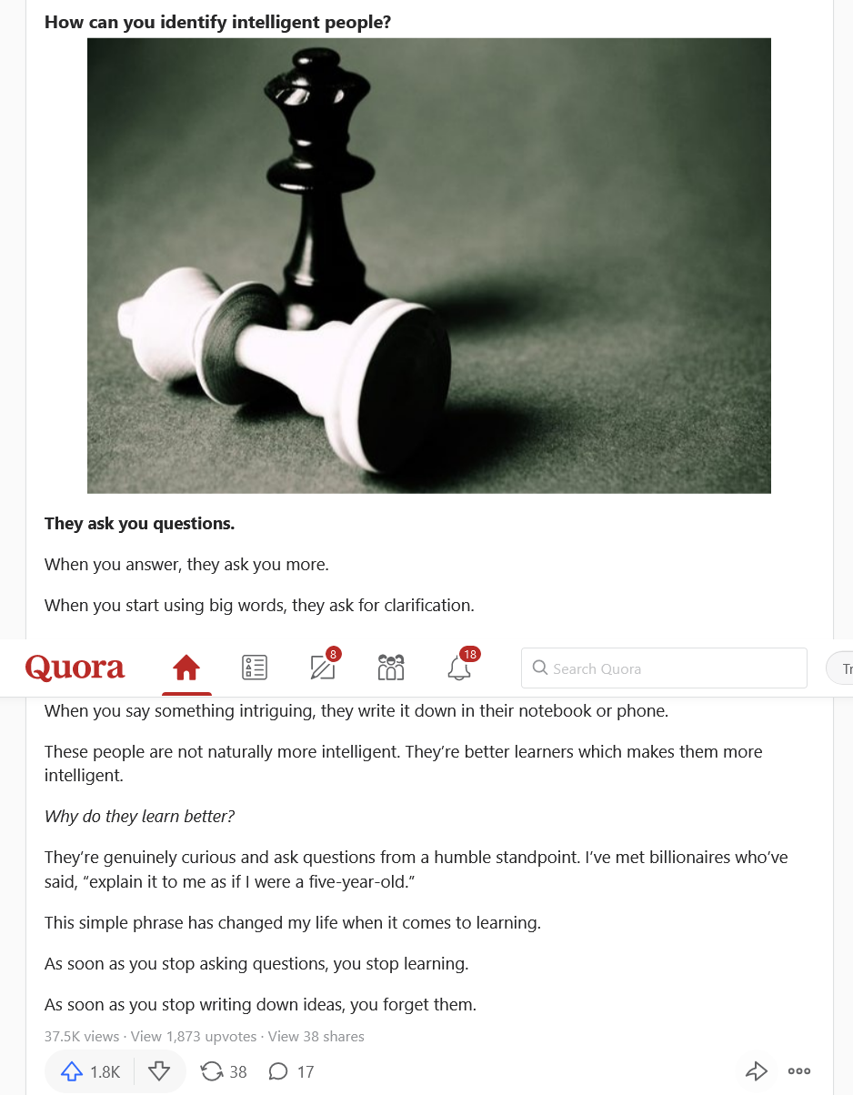

**Action to become good in every field**

1. Ask more questions
2. Write down ideas
3. Take a note of everything you will learn. If not, you will soon forget them

**“No One is better than you, they just do things differently”**

You can do and achieve what others have done if you get to know how they did it.

**Example,** Elon must is know to have achieve many things in life. Why because he works differently done others. Whiles others work from 9:00am to 6:00pm only, he works from 7:00am to 1:00am.

So if you think someone is better than you, he is just doing things differently than you do. So just ask the person how he does those things. For example, if you’re in school and one of your mates always tops the examination, just ask him how he learns and do the same simple.

**“Is not about the hours of sleep you get, it about what you do when you’re awake”**

For example, if you sleep only 3 hours a night and procrastinate the next day and put in only 1 hour work. The person that sleeps 8 hours and put in 5 hours of work will surely succeed than you even though you sleep less hours than he do.

**”Always go for what you don’t have not what you already have”**

